**Musician Biopics, Or:**

**Music, Film, and the Ideology of Genius**

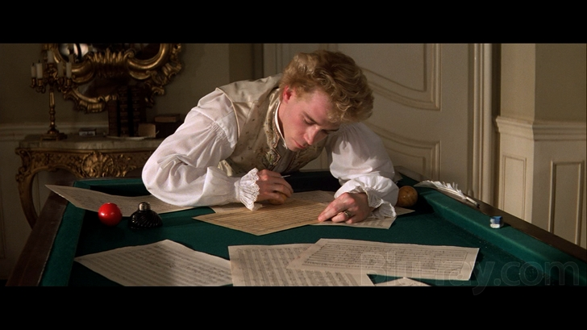

This course examines the way visual and aural myths about Western Art Music composers are constructed in film. The history of the musician biopic runs as long as the history of film—something that tells us that the mythical act of creating music has long been the object of narrative desire. We want these stories to be told, we want to hear and see them, and there are stylistic patterns to the way these stories are told. The musician biopic is often entertaining, camp, and occasionally arrestingly beautiful; it relays all kind of complex political and aesthetic information. Often, for instance, these films make a point about the superiority of certain European heritages; they also tell us something about who can create music, and how, it tells us what inspiration and creativity ought to look like, and it teaches us how to look and listen out for that ineffable, most white masculine quality: “genius”. In this class, you will learn to examine the way you respond to the content of these stories about music and composition—to the way that sound and film work together. We will use technical skills from film theory, music history, as well as musical analytical skills in order discuss musical compositions, composer biographies, and critical literature about the racial, gender, and class implications of musical genius.

You will come away from this class with sharpened analytical skills in film and music, and with an ability to discuss critically the role of musical creativity in Western society. Furthermore, you will be engaged in creative projects that require you to use your skills to interpret some of the stylistic patterns, tropes, and narrative devices and make decisions about how—and whether—the musician biopic is a thing of the past, present, or future.

**Grade Breakdown:**

* 10% Attendance
* 30% In-class participation
* 30% Weekly Assignments and Discussions on bCourses
* 10% Mid-Term project (Due Week 7)
* 20% Final Project (including Presentations on Weeks 14-15)

***

Week 1: January 22

**What is a Musician Biopic?**

**+ Basics of Film Analysis and Soundtrack Analysis**

Week 2: January 29

**Musical Genius and Its Representation**

Reading:

* Peter Kivy, *The Possessor and the Possessed: Handel, Mozart, Beethoven, and the Idea of Genius*, chapter 1 (“Time out of Mind”) and 2 (“Greatness of Mind”)
* Marjorie Garber, “Our Genius Problem,” in *Loaded Words*

Week 3: February 5 **Back to Beethoven (on Film)**

Reading:

* Nicholas Cook, “Back to Beethoven,” from *Music: A Very Short Introduction*
* Scott Burnham, “Beethoven’s Hero” from *Beethoven Hero* (Princeton University Press, 199x)

Watching:

* *Un grand amour de Beethoven* (Abel Gance, 1937)
* *Ludwig Van* (Mauricio Kagel, 1970)
* *Immortal Beloved* (Bernard Rose, 1994)

Week 4: February 12 **Sibling Myths—Mozart and Haydn**

Reading:

* Alexander Pushkin, *Mozart and Salieri* (1830)
* Joseph Haydn, “Autobiographical Sketch” (1776)
* [Vernon Gotwals, “The Earliest Biographies of Haydn,”](https://www.jstor.org/stable/740595?seq=1) *[Musical Quarterly](https://www.jstor.org/stable/740595?seq=1)*[, October 1959](https://www.jstor.org/stable/740595?seq=1)

Watching:

* *Amadeus* (Miloš Forman, 1984)
* *Mozart and Salieri* (Nikolay Rimsky-Korsakov, 1897, production by x in xxxx)
* *In Search of Haydn* (Phil Grabsky, 2012)
* [7-minute lego movie on Haydn](https://www.youtube.com/watch?v=pjAlVWxKoYo)

Week 5: February 19 **From Silent Film to Sound Film (Race, Medium, Nation)**

Watching

* [*The Life and Works of Richard Wagner*](https://archive.org/details/SILENTWAGNER1913) (Karl Froelich, 1913)
* *The Jazz Singer* (Alan Crosland, 1927)

Reading:

* Peter Franklin, “The life and works of Richard Wagner (1913): Becce, Froelich, and Messter” in *Wagner & cinema*, edited by Jeongwon Joe and Sander L. Gilman (Indiana University Press, 2010.
* Michael Rogin, “Blackface, White Noise: The Jewish Jazz Singer Finds His Voice,” Critical Inquiry, Vol. 18, No. 3 (Spring, 1992), pp. 417-453

Week 6: February 26 **Nationalist Grand Narratives: 1940s Cinema**

Watching:

* *Rhapsody in Blue* (Irving Rapper, 1945)
* *Rhapsody in Black and Blue* (Aubrey Scotto, 1932)
* *Symphony in Black: A Rhapsody of Negro Life* (Duke Ellington)
* *Friedemann Bach* (Traugott Müller, 1941)
* *A Song to Remember* (Charles Vidor, 1945)

Reading:

* “Hitler’s Phantom” from *The Ministry of Illusion: Nazi Cinema and Its Afterlife* (Harvard University Press, 1996)
* TBA

Week 7: March 4 **Attempts at Subversive Narrative (I)**

Watching:

* *Lisztomania* (Ken Russell, 1975)
* *The Double Life of Franz Schubert* (Peter Webber, 1997)
* *The Music Lovers* (Ken Russell, 1970)

Reading:

* Maynard Solomon, “Franz Schubert and the Peacocks of Benvenuto Cellini.” *19th-Century Music*, vol. 12, no. 3, 1989
* Edward Rothstein, *Critic's Notebook; Was Schubert Gay? If He Was, So What? Debate Turns Testy*, New York Times, 4 February 1992.
* TBA

Week 8**:** March 11 **Attempts at Subversive Narrative (II)**

Watching:

* *Vision* (Margarethe Von Trotta, 2009)
* *Tous les Matins du Monde* (Alain Corneau, 1991)
* *Round Midnight* (Bernard Tavernier, 1986)

Week 9: March 18 **Carla Shapreau (Curator of the Salz Collection), Guest Seminar**

Watching:

* *The Red Violin*

Reading: TBA

**Week 10 SPRING BREAK!**

**Week 11**: April 1 **Olivia Ting (Video Artist),** **Guest Seminar on Video Narratives**

**Week 12**: April 8 **Beyond Feature Film: Documentaries (I)**

Watching:

* *Jazz on a Summer’s Day* (1959)
* *I Called him Morgan* (2016)
* *What Happened, Miss Simone?* (2018)

Reading:

TBA

**Week 13**: April 15 **In-Class Workshop of Presentation Ideas**

**Week 14**: April 22 **Presentations**

**Week 15**: April 29 **Presentations**

**Final Projects** Due May 6